**COMPUTER NETWORKS LABORATORY-18CSL51**

NANDHAKUMAR R G

19CSR117

**EXERCISE-5**

**AIM:**

To implement ARP and RARP.

**ARP PROGRAM:**

int main()

{

FILE *arptable;

int i,d,n;

char mac[50],ip[50],inpip[50];

arptable = fopen("ARPdata.txt","r");

printf("**\t ADDRESS RESOLUTION PROTOCOL \t**");

if(arptable==NULL)

printf("\nCan't open the file");

else

{

printf("\nEnter the IP address of the host: ");

scanf("%s",inpip);

while((fscanf(arptable,"%s%s",ip,mac))==2)

{

if(strcmp(inpip,ip)==0)

{

printf("Equivalent MAC Address: %s",mac);

break;

}

if(feof(arptable))

printf("Equivalent MAC Address is not available. Please Update the database!");

}

}

return 0;

}

**ARPdata.txt:**

IP MAC

192.168.1.1 00:12:22:43:49:46

192.168.25.5 00:19:55:25:1a:d0

129.21.153.254 00:00:5c:07:ac:01

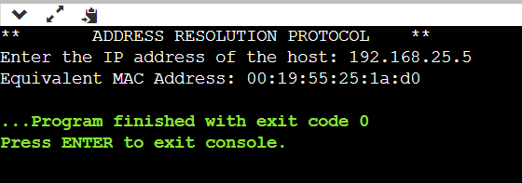**OUTPUT:**

**RESULT:**

Thus, the program for ARP implemented successfully.

**RARP PROGRAM:**

int main()

{

FILE *arptable;

int i,d,n;

char mac[50],ip[50],inpmac[50];

arptable = fopen("RARPdata.txt","r");

printf("###\t REVERSE ADDRESS RESOLUTION PROTOCOL \t###");

if(arptable==NULL)

printf("\nCan't open the file");

else

{

printf("\nEnter the MAC address of the host: ");

scanf("%s",inpmac);

while((fscanf(arptable,"%s%s",ip,mac))==2)

{

if(strcmp(inpmac,mac)==0)

{

printf("Equivalent IP Address: %s",ip);

break;

}

if(feof(arptable))

printf("Equivalent IP Address is not available. Please Update the database!");

}

}

return 0;

}

**RARPdata.txt:**

IP MAC

192.168.1.1 00:12:22:43:49:46

192.168.25.5 00:19:55:25:1a:d0

129.21.153.254 00:00:5c:07:ac:01

**OUTPUT:**

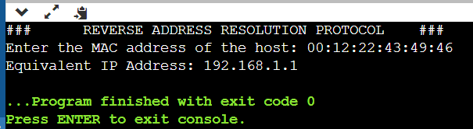

**RESULT:**

Thus, the program for RARP implemented successfully.